- \Operation\Carton transfer\Infeed conveyor
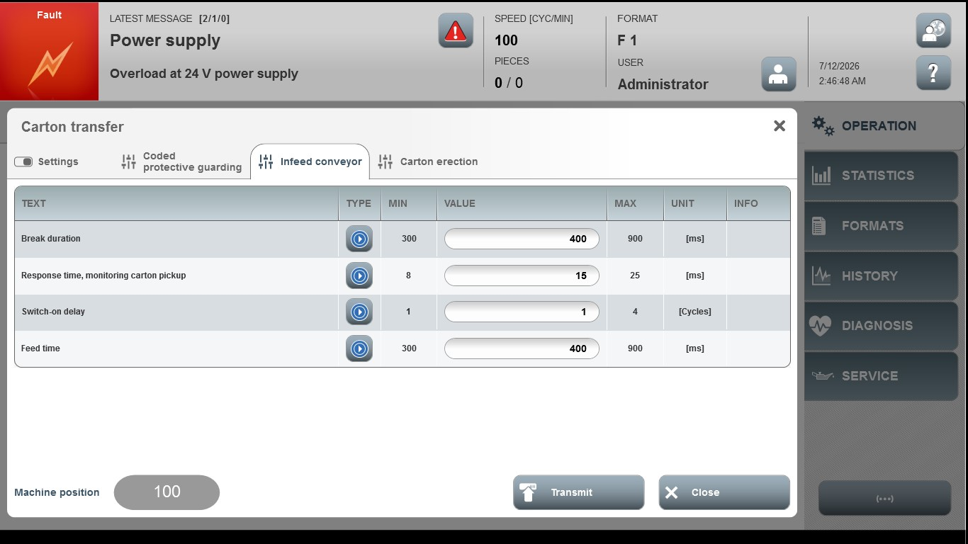

Acceptance criterion | Limits | Pass / Fail: Dev-No. | Date | Initials
Screen matches screenshot | N / A
Break duration | 300 … 900
Response time, monitoring carton | 8 … 25
Switch-on delay | 1 … 4
Feed time | 300 … 900

